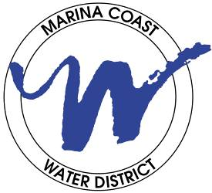
MARINA COAST WATER DISTRICT
& GROUNDWATER SUSTAINABILITY AGENCY

920 SECOND AVENUE, MARINA, CA 93933-6009
District Office: 831-384-6131 Website: www.mcwd.org

DIRECTORS

GAIL MORTON
President

JAN SHRINER
Vice President

BRAD IMAMURA
THOMAS P. MOORE
STACEY SMITH

October 5, 2026

Vogl, Frank
13195 Paseo Barranco

Salinas, CA 93908

Re: Billing Adjustment for July and August 2026

Dear Vogl, Frank,

We sincerely apologize for an error in your bills for July and August 2026. The approved rates effective July 1, 2026 were not applied correctly, resulting in incorrect charges to your account.

We have corrected the discrepancy in the system and recalculated the affected charges on your account.

The adjustment will appear on your next billing statement and covers only the difference between the original charges and the charges under the approved rates. The attached summary shows the original and corrected bill totals, each service adjustment, and the total adjustment for your account.

We understand that an unexpected adjustment can be frustrating, and we sincerely apologize for the inconvenience. Late fees have been suspended while the District completes these billing adjustments.
If you are experiencing financial hardship and need assistance, please do not hesitate to contact us. We are here to help.

We take responsibility for this error and appreciate your patience as we correct it.

If you have questions or would like help reviewing the attached summary, please contact Customer Service at 831-384-6131.

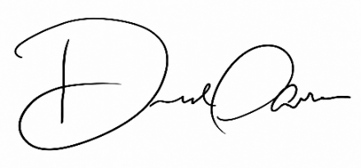
Sincerely,
Derrell Parker, Customer Service Administrator
Marina Coast Water District
Customer Service
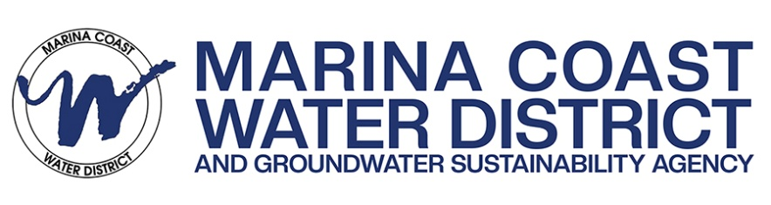

Marina Coast Water District
July and August 2026 Billing Adjustment Summary

Customer: Vogl, Frank
MCWD Account Number: 000725-000

Service | Billing Period | Original  Amount | Corrected Amount | Difference
Sewer July 2026 $25.28 $27.62 $2.34
Sewer August 2026 $371.74 $375.61 $3.87
Total Adjustment |  |  |  | $ 6.21

The corrected amounts use the approved service rates effective July 1, 2026. The total adjustment will appear on your next billing statement.

For questions, please contact Customer Service at 831-384-6131.

